**PUBLISH DATA TO THE IBM CLOUD**

|  |  |
| --- | --- |
| Date | 17 September 2022 |
| Team ID | PNT2022TMID47453 |
| Project Name | Project - Industry-Specific Intelligent Fire  Management System |

**OUTPUT OF PYTHON SCRIPT:**

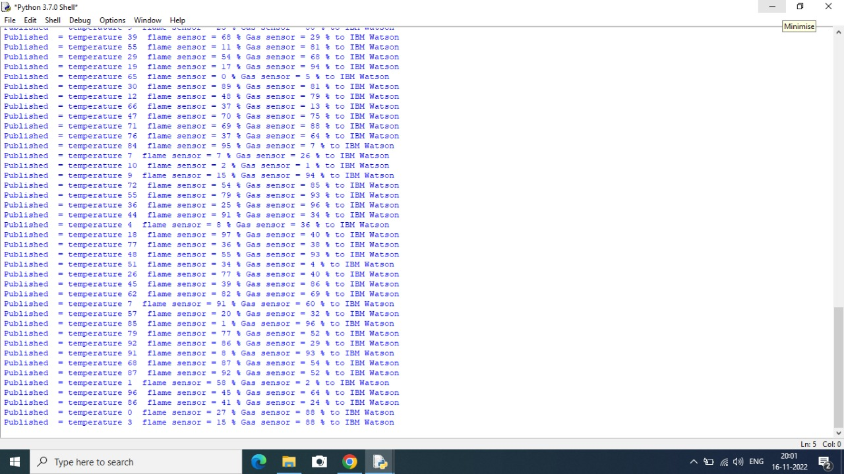

**OUTPUT OF IBM WATSON CLOUD:**

